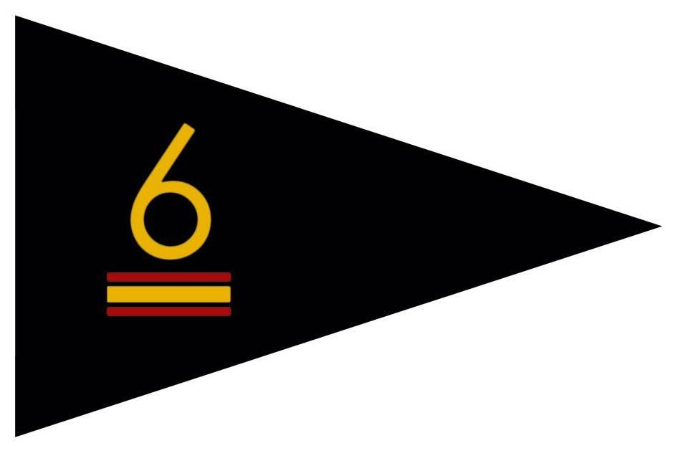
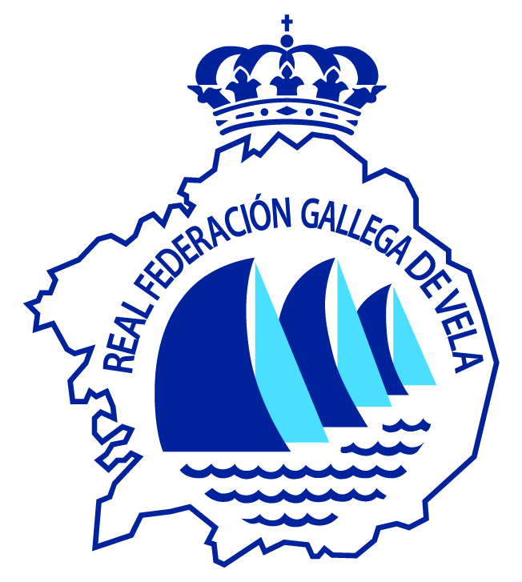

SPANISH CUP 2020 6 METRES CLASS

ENTRY FORM
BOAT NAME | CLASS | YACHT CLUB
SAIL NUMBER | DIVISION | RACE PHONE
OWNER
SKIPPER |  | SPORTS LICENSE AND COUNTRY FEDERATION
MAILING ADDRESS

CERTIFIED PHOTOCOPY MEASUREMENT |  | PHOTOCOPY SAFE SHIP
PHOTOCOPY PAYMENT REGISTRATION |  | PACCIDENT INSURANCE COPY

CREW NAME | SPORT LICENSE |  | CREW NAME | SPORT LICENSE

I agree and assume any responsibility from the construction of my ship and rig, as well as its safety conditions, of compliance with the provisions in force, both of the authorities of the Civil Navy, and of the authorities Sports, and how much I can occur because of not strictly complying with the established. With this statement and for what it refers to me and my crew, I am relieved of all responsibility to the Real Club Náutico Sanxenxo,, Clase 6 Metros Spain, and those who collaborate with this regatta, to the Royal Spanish Sailing Federation, the Galician Sailing Federation, as well as the race committee, the protest committee, any natural or legal person participating in the organization of this regatta, for any title, assuming in my charge any damage or injury that may result from my participation in the regatta. Also, I authorize the organization of this regatta to disseminate in all kinds of media written and audiovisual, the images collected in the event.

DATE | SIGNATURE OF THE SKIPPER OR OWNER

